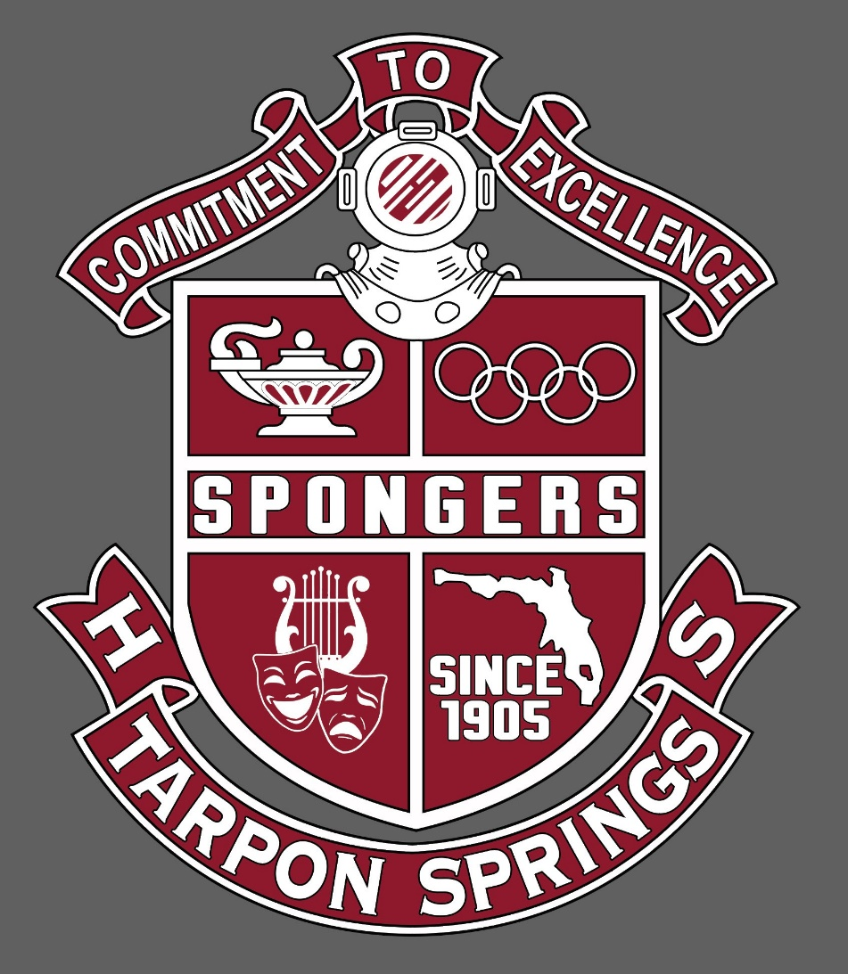

State of the School Report

TSHS
Tarpon Springs HS  January 2022  Principal Fatolitis | GO SPONGERS!!!  www.pcsb.org/tarpon-hs

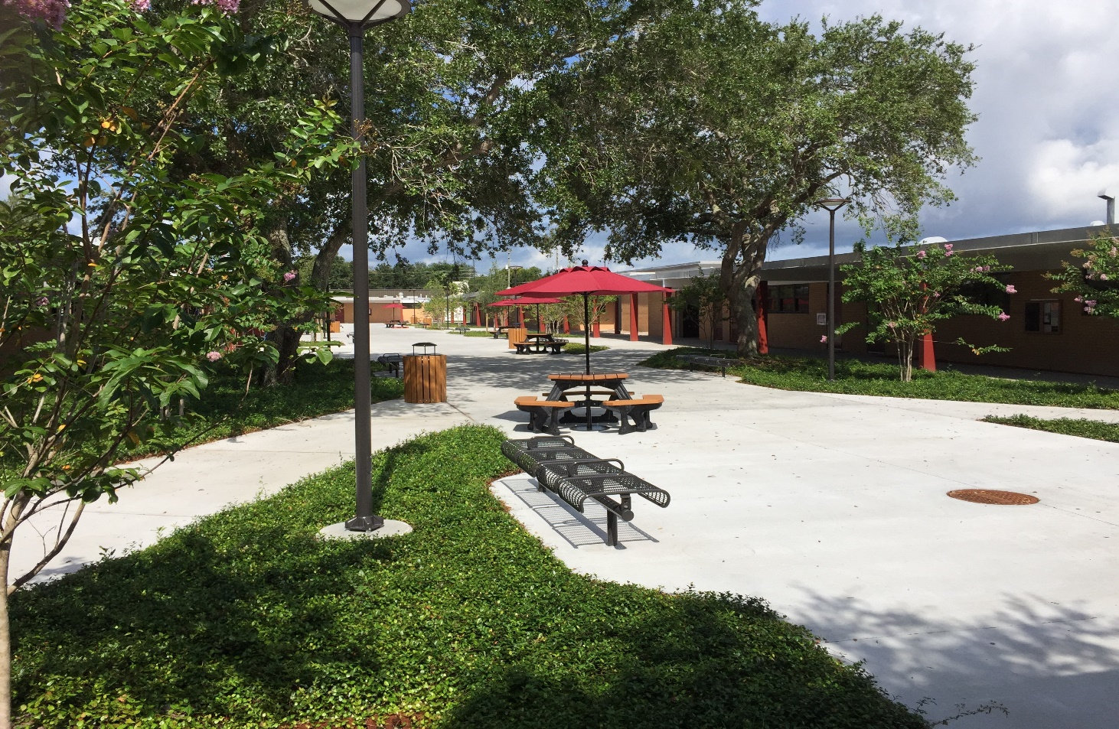

Campus Highlights

Enrollment: 1182 Students
Staff: 100 (67 Teachers + 32 Support Staff), (2) SRO’s + (1) Campus Monitor
Graduation Rate: 98%
PCS Connects – 1:1 Computer Device for all Students in Grades 9 and 10.

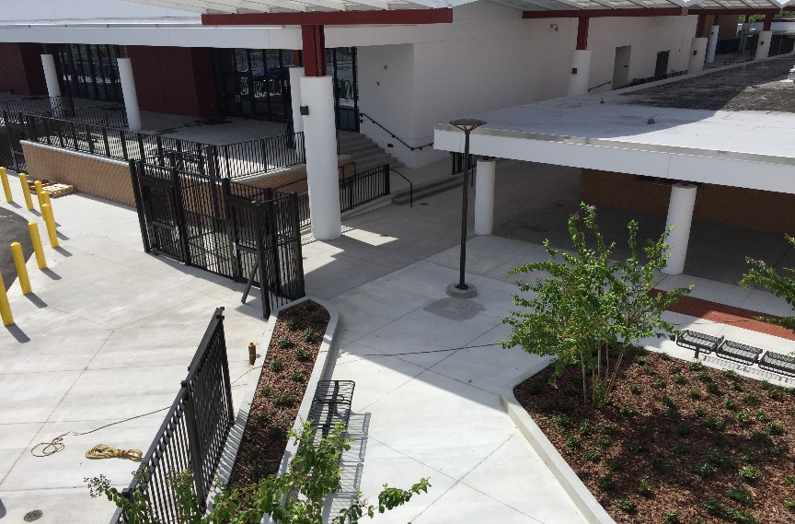 |  | 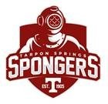

Curriculum
- FL Standards based curriculum supported by PCS Teaching and Learning Department

- AICE and Advanced Placement course work in addition to Dual Enrollment opportunities – Pinellas Technical College, SPC, with articulation for USF and UF dual enrollment courses.

- (5) Magnet Programs: AICE, Leadership Instrumental, Vocal, Culinary Arts and Veterinary Science

At TSHS, our mission to prepare every student to be a productive citizen and provide them with the skill set necessary to be successful in life.

Athletics & Extracurricular
15 Athletic Teams
Upgraded Football Locker Room with Collegiate Lockers
Upgraded Weight and Training Center
Remodeled Color Guard and Dance Training Center
Nationally Recognized and Renowned TSLCA Marching Band
Academic Clubs
Community Based Service Clubs
Sponsorship with Advent Health
Sponsorship with Pinellas Education Foundation – Ryan Wells Foundation
Dual Enrollment – Pinellas Technical College for TSHS Culinary and Early Childhood Academies
Little Spongers’ Preschool - $60 week/per student (age 3 or 4) M – F

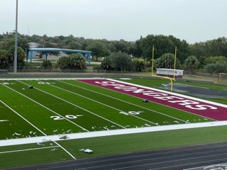 | Culture  Social Emotional Support – Self Care  School Wide Expectations for success for all students  Free After School Tutoring – Core Classes  Student Government
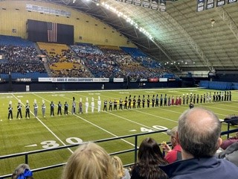 | Extra-curricular  Nationally Competing Band, Chorus and Guard  Leadership Conservatory – Outdoor Performance Ensemble – Macy’s Thanksgiving Parade 2022
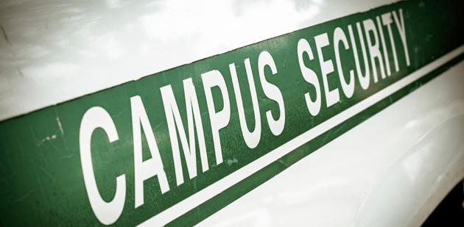 | Safety  Monthly Safety Drills & Site Safety Committee  Safer Watch APP for Staff  Annual Training on Active Assailant Measures  Tarpon PD Support  SROs – Officer O’Neill and Theil

